Border Style

The border-style property specifies what kind of border to display.

The following values are allowed:

* dotted - Defines a dotted border
* dashed - Defines a dashed border
* solid - Defines a solid border
* double - Defines a double border
* groove - Defines a 3D grooved border. The effect depends on the border-color value
* ridge - Defines a 3D ridged border. The effect depends on the border-color value
* inset - Defines a 3D inset border. The effect depends on the border-color value
* outset - Defines a 3D outset border. The effect depends on the border-color value
* none - Defines no border
* hidden - Defines a hidden border

Margin - Individual Sides

CSS has properties for specifying the margin for each side of an element:

* margin-top
* margin-right
* margin-bottom
* margin-left

Padding - Individual Sides

CSS has properties for specifying the padding for each side of an element:

* padding-top
* padding-right
* padding-bottom
* padding-left

# CSS - Outlines

Outlines are very similar to the borders but there are few major differences in borders and outlines:

* An outline does not take up space.
* Outlines do not have to be rectangular.
* Outline is always the same on all sides; you cannot specify different values for different sides of the element.

**NOTE:** The outline properties are not supported by IE 6 or Netscape 7.

You can set following outline properties using CSS.

* The **outline-width** property is used to set the width of the outline.
* The **outline-style** property is used to set the line style for the outline.
* The **outline-color** property is used to set the color of the outline.
* The **outline** property is used to set all the above three properties in a single statement.

## **The CSS Box Model**

All HTML elements can be considered as boxes. In CSS, the term "box model" is used when talking about design and layout.

The CSS box model is essentially a box that wraps around every HTML element. It consists of: margins, borders, padding, and the actual content. The image below illustrates the box model:

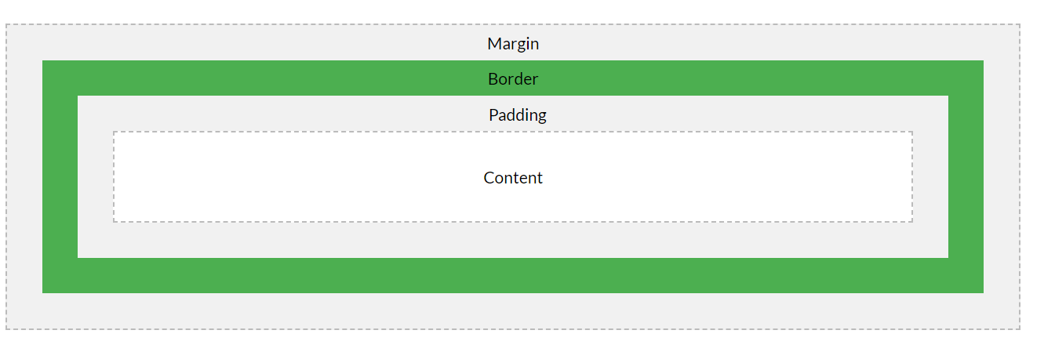

Explanation of the different parts:

* **Content** - The content of the box, where text and images appear
* **Padding** - Clears an area around the content. The padding is transparent
* **Border** - A border that goes around the padding and content
* **Margin** - Clears an area outside the border. The margin is transparent